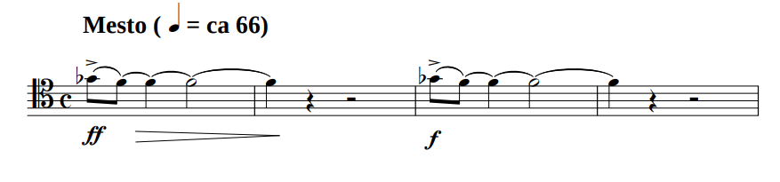
Question 0 (0/1)
Looking at the visual information on the image, can you find any kind of music representation in it? Answer only with “Yes”, if there is any kind of music representation on the image, or “No”, if there is not.
1 | “Yes” (for all scores)
0 | “No”
Question 1 (0/1)
What type of musical notation is used in this excerpt? Choose between: modern notation, tablature, mensural notation, Korean notation, “other notation” or “no music notation present”. Answer only with the name of the musical notation used in the excerpt.
1 | “Modern notation”, “Common western notation”... (for all scores)
0 | Any other answer
Question 2 (0/1)
Based solely on the music sheet image provided, can you determine which musical work this excerpt belongs to? Please use the melody’s rhythmic patterns, note sequences, and any other musical clues to make your deduction.
1 | Cántico de soledad (José Miguel Moreno Sabio)
0 | Any other answer
Question 3a,b,c (SER)
Please transcribe the contents of the given music excerpt in the Kern formats. For your information, Kern/MusicXML/ABC format is a text-based format for encoding musical scores. Ensure the excerpt's musical notation is accurately encoded in the Kern/MusicXML/ABC syntax, capturing the pitch, rhythm, and any relevant musical details.
Make sure you are familiar with the Kern format when performing the transcriptions. Provide the transcript only for what is visible in the image, even if you have more knowledge.
SER | Compare the model’s transcription with the ground truth.  This agreement will be computed automatically, not by the evaluators.
Question 4 (1-5)
Can you determine the tonality (key) of the given music excerpt? Please explain the steps and reasoning behind how you arrived at this conclusion.
When determining the tonality, consider the following factors:
- Key signature: Whether there are any sharps or flats.
- Accidentals: Notes altered by sharps, flats, or naturals outside of the key signature.
- Melodic structure: The shape and direction of the melody, including important pitches and phrase endings.
- Harmonic implications: Some melodies imply certain harmonic progressions or tonic-dominant relationships.
Provide a clear explanation of your process, detailing how each of these elements contributes to your conclusion about the tonality.
5 | The reasoning contains:  - “The key signature shows no sharps nor flats”  - “The key signature suggests C Major [Do mayor] or A minor [La menor]”  - “The melodic major scale has its sixth and seventh degree lowered by one semitone, which might be coherent with the A♭ (sixth degree of C Major).”  - “With that little amount of information, we cannot draw a conclusion.”  Conclusion: “C Major”, Unsure
4 | The reasoning contains:  - “The key signature shows no sharps nor flats”  - The reasoning is not completely correct  Conclusion: “C Major”, Unsure
3 | The reasoning contains:  - “The key signature shows no sharps nor flats”  Conclusion: The key tonality is C Major [Do mayor] or A minor [La menor], with certainty
2 | The reasoning contains:  - The key signature is mistaken, but only a single symbol up or down: in this case, it could say it has one sharp (F#) or or one flat (B♭)
1 | The key signature is mistaken
Question 5 (1-5)
Based on the musical notation present in the image, what instrument do you think it is intended for? Your task is to analyze the musical notation and use the melody's structure, rhythm, and characteristics to deduce the most likely instrument the musical work was written for.

5 | The reasoning contains:  - “The notation is simple and clean without instrument-specific markings or techniques that would suggest a particular instrument.”  - Tenor clef (C-clef on the fourth line)  - “The tenor clef is used for basson, cello, tenor trombon and euphonium.”  Conclusion: “Cello”, but is very explicit about having doubts because of the few clues in this fragment.
4 | The reasoning contains: The previous arguments  Conclusion: “Basson”, “tenor trombon”, “euphonium”, but is very explicit about having doubts because of the few clues in this fragment.
3 | The reasoning contains: The previous arguments  Conclusion: Mentions any monophonic instrument but is very explicit about having doubts because of the few clues in this fragment.
2 | Does or does not mention the previous arguments, but provides a very clear and sure answer.
1 | Provides a very clear and sure answer without argumentation.
Question 6 (0/1)
Based on the musical notation present in the image, what is the time signature?
1 | “4/4, notated as a C at the beginning of the staff”
0 | Any other answer
Question 7 (1-5, cuántos identifica correctamente)
In this excerpt, are the following symbols present?
Quarter note (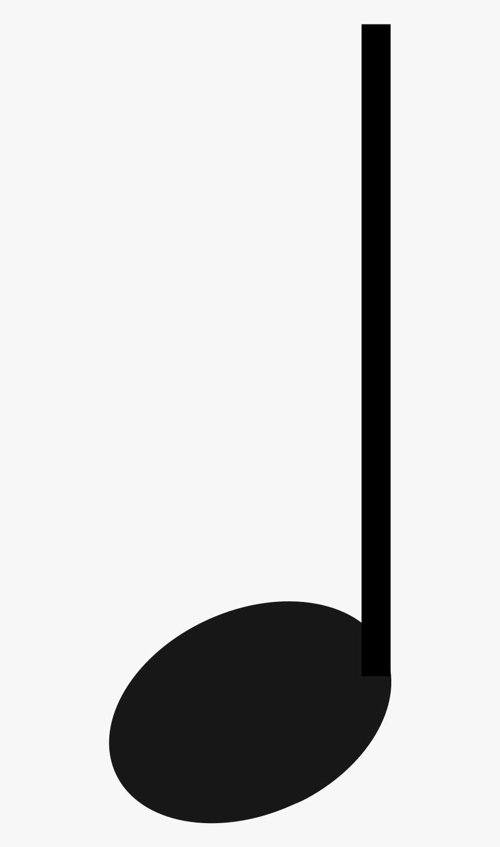) | Yes
Whole note () | No
Crescendo indicator  (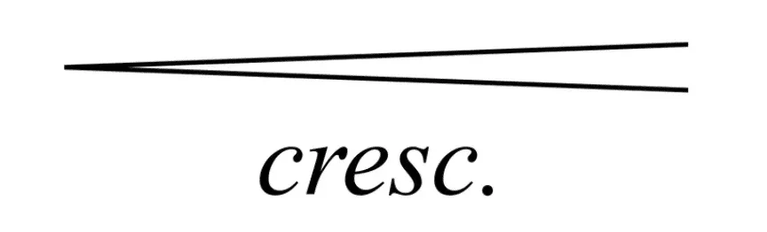,) | No, “but there is a decrescendo in the first measure”
C major chord | No
Quarter rest (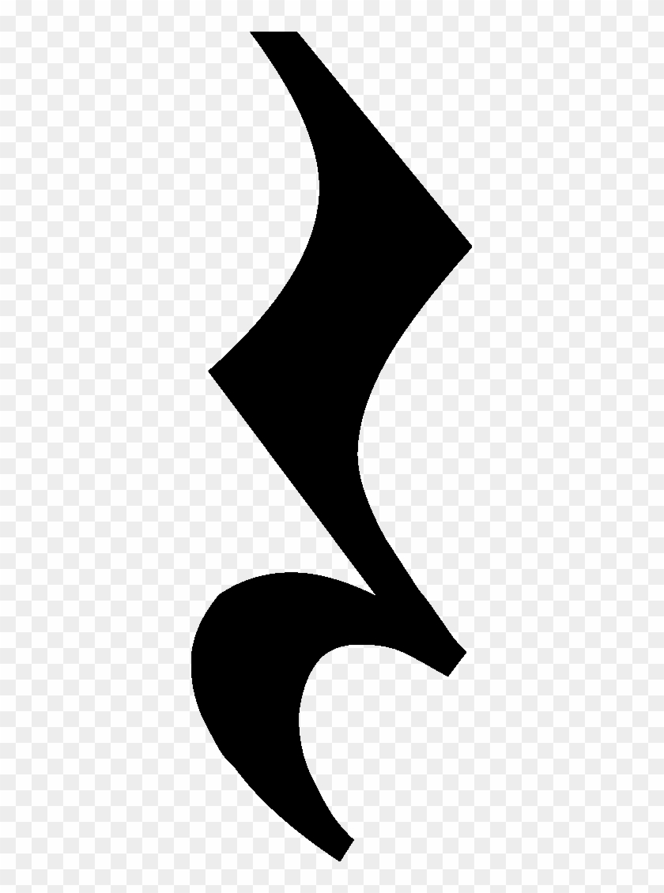) | Yes
Question 8a (0/1)
Is there information about the speed at which the piece should be played? (e.g., tempo markings like Allegro, Andante, or a BPM number)
1 | “Yes”, at the top of the first measure, above the staff, the word "Mesto" is clearly indicated, as well as the specific metronome marking of ♩= 66.
0 | “No”, or does not recognize the “Allegretto”.
Question 8b (0/1)
Are there any articulation marks indicating how the piece, or a segment, should be played? (such as ties, legato slurs, dots for staccato, or other articulation marks)
1 | “Yes”, there are many legato slurs and ties, as well as accents
0 | “No”
Question 8c (0/1)
What clefs, if any, are present in this image of the staff?
1 | “Yes”, “tenor clef”, “C-clef on the fourth line”
0 | “No”, o Any other answer
Question 9 (0-1)
Based on the musical notation present in the image, how difficult do you think it is to play the excerpt? Rate from 1 to 5, where 1 is easiest and 5 hardest.
1 | - “Easy”, 1-2  - “For a low-pitched instrument”  - “Very few notes”  - “Very simple rhythm”
0 | “Difficult”, 3-5, or hallucinates
Question 10a (melody present) (0/1)
In this excerpt, can the melody “A♭ G A♭ G” be found in the excerpt?
1 | “Yes”
0 | “No”, or any other answer
Question 10b (melody not present) (0/1)
In this excerpt, can the melody “G G A♭ B♭” be found in the excerpt?
1 | “No”
0 | “Yes”, or any other answer

